Gretton Village Traffic Report 2022
Introduction
In response to concerns expressed by a number of village residents regarding the speed of traffic in parts of the village, concerns for safety and a desire to implement the Community Actions from the Neighbourhood Plan, the Parish Council set up a Traffic Sub-committee in early 2022.
This committee was tasked with reviewing and identifying current traffic issues and reporting back to the Council with recommendations. Guidance From the Department of Transport was considered during this review, this is an extract.
‘Speed and accident reduction are not the only valid objectives leading to the introduction of a traffic calming scheme. Other objectives may include encouraging non-motorised users, improving the local environment.. ’DOT Doc. Traffic Calming 1.1.11
As part of the review we involved Gretton residents, giving them an opportunity to contribute to a redesign of the street scene by running a traffic/street environment survey within the village. This was circulated to all dwellings in Gretton by the Parish council.
140 survey forms were completed, details of the responses are contained within this report.
The Survey sought to establish the views of parishioners, to identify issues regarding the traffic environment within the village and to establish whether a 20 mph speed limit would be supported. A copy of the survey is attached. Along with the issues raised, the Survey sought to record the experiences of people moving around the village and to obtain suggestions to resolve issues raised. The survey results are detailed below and only record the views of participants.
Concerns around the following junctions were the main issues expressed in the survey:
- Kirby Road/Corby Road/High St, Station Rd at the junctions with High St. – Parking, Vehicles causing obstructions, restricted view.
- School Road/Kirby Road. Parking, speed, obstructions particularly at school times.
- Clay Lane/Station Road. Restricted view, speed of vehicles travelling down Station Road
- Caistor Road/Kirby Road and High Street. Restricted view, narrow road.
- Station Road/Kirby Road/Harringworth Road. Restricted view, speed of vehicles.
Corby Road, Kirby Road, Station Road and the High St were highlighted due to the speed of vehicles over their entirety.
Craxford Road mentioned due to its use as a ’rat-run’ at the beginning and end of the day.
Poor parking on Arnhill Road near to Clay Lane and The Maltings is an issue.
Speed of vehicles was the main concern in the village, the locations where this is predominant are listed within the report. The option to reduce the speed limit in the village to 20mph was presented in the Neighbourhood Plan and accepted by referendum, the Plan was agreed by the local authority and therefore there is some onus on them to help the village to achieve this Community Action.
Parking is the biggest issue after speed. This can be divided into poor on-road parking and parking on the footpath. Parking causes congestion and this is an issue at the start and end of school, it has caused problems for pedestrians and motorists using Kirby Road and School Lane and contributes to people feeling less safe. One suggestion is to have a ‘lollipop’ person at the relevant times.
Parking can also contribute to reducing the speed of traffic, this is particularly true of Kirby Road where speed is the biggest issue.
Parking around the top of the High Street at the bend where it runs in to Corby road is causes problems and there are a significant number of near misses here.
Parking on the footpath is illegal, there are a number of places around the village where this occurs and causes pedestrians and users of disability scooters to use the road.
Caistor Road reports the most near misses after the main roads in the village for pedestrians walking in the road and vehicles using the junctions at either end.
A number of junctions have restricted views due to vegetation and a number of footpaths are restricted for the same reason, this is particularly true of Station Road where the path is very narrow, buggies and wheelchairs have to use the road if the hedge is not cut back regularly.
Consideration has been given to large and Heavy Goods vehicles that do need access to the village and a proposal is listed in the recommendations below
Quick wins.
- Enforce/educate regarding the highway code in respect of parking at junctions and on the footpath.
- Cut back hedges where it is the Council’s responsibility. [This is an extract from West Berkshire Council guidance.]
The Council has a duty under the Highways Act 1980 to ensure that the highway is not obstructed. Even small overgrowths can be hazardous particularly to blind and visually impaired people who often use property boundaries as a guide, or when a footpath is narrow. It is also a requirement that anything overhanging a footway must be at least 2.3m above the footway, cycleway, verge and 5.3m above the road surface.

It is an offence under the Highways Act 1980 to allow trees, hedges, shrubs and so on to obstruct the highway. The Council will, after an initial informal request, serve a 21 Day Notice on you, the occupier, to cut back the offending vegetation. If you do not comply with the Notice, the Council may carry out the work itself and recover it’s costs in doing so from you, through the courts if necessary.

- Place TVASS at all entrances to the village. The data from the installed speed indicator on the Corby Road shows the Following: (DATA REQUIRED)
From speaking to residents who live on Corby Road and other residents of Gretton who use the road regularly, there has been a significant impact on the speed of vehicles entering the village, however not on vehicles exciting. (A number of vehicles accelerate from Corby Road, well before the national speed limit.)

- Some of the proposals would be a lot less expensive than others to implement and a number of these could be introduced first.
The proposals in this report have not been costed, however they do represent a significant change to traffic management in the village and will contribute to safety and quality of life to all Highway users.
The proposals are obviously subject to consideration and review by various legal and local government bodies.
Positioning of signs, road markings, yellow lines and or parking restrictions would need to be surveyed.
There is specific guidance from Government with respect to traffic calming and these proposals will need to comply with them.
It is the recommendation of the committee that the village becomes a 20 mph zone within the village boundary. Research shows that a small zone around a school is not very effective. The establishment of a 20 mph zone without traffic calming is not very effective either. ’DOT Doc. Traffic Calming Guidance
This report is submitted to the Parish Council for consideration.
The Committee.
Trevor Smith Paul Britton David Hall
Mark Thompson Steven Gray

Part 1 Survey Results
Question 1 How people move around the village.

As can be seen, of the respondents, walking and use of motor vehicles are the main modes of transport, with a significant number of cyclists, other road users include horse riders and mobility scooter.

Question 2. With regard to traffic, do you feel safe when moving around the village?

The Chart shows more than half the respondents do not feel safe at times moving around the village, a few roads and junctions are the main causes of concern.

Question 3 shows that significant number of participants who generally feel safe recognise that there are areas in the village where roads could be safer.

Answers to questions 4 to 8 identify those hotspots in the village where people feel less safe, have had near misses/accidents and where speed is a cause for concern.

Question 9 asked ‘Do You think a 20 mph speed limit would benefit the village. The Chart below is quite clear.

Support is very high for a 20 mph limit, This was included within the neighbourhood plan as a community action and as such this report looks to have these elements of the Neighbourhood plan action.
Questions 10,11, and 12 sought views on what issues there are in the village and any ideas and suggestions to resolve them.
The following charts summarise them main points raised.

There is significant support for traffic calming and parking restrictions (yellow lines/no parking). These and all the other resolutions have been considered by the Traffic committee and have charted the issues and the suggested resolutions onto a number of maps.

Part 2 Traffic Calming Proposals
Proposal for Traffic Calming Corby Road.

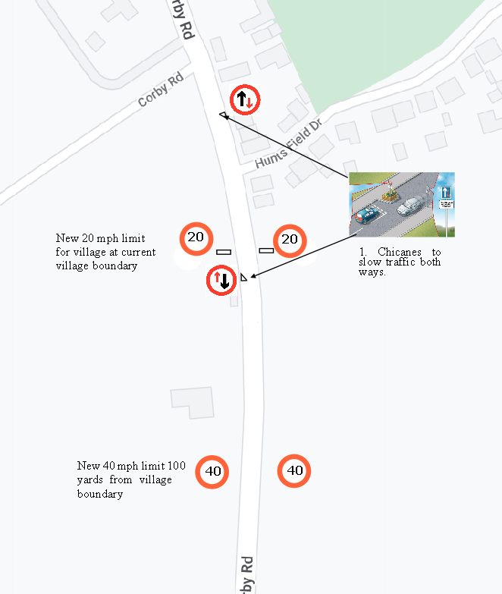
This option, has a double chicane to reduce the speed of vehicles in both directions. The positions of these chicanes is representative.

Proposal for Traffic Calming - Rockingham/Lyddington Road
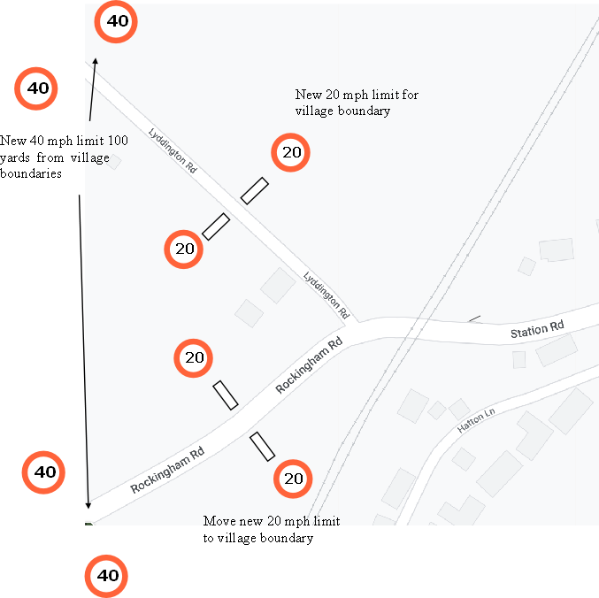
The village speed limits on the Lyddington and Rockingham Roads are currently too close to their junction with Station Road, Drivers are presented with a 30 mph limit immediately coming round a bend on the Rockingham Road. By moving them back, vehicles will have time to slow the limit entering the village.

Station Road/Clay Lane Junction – proposal

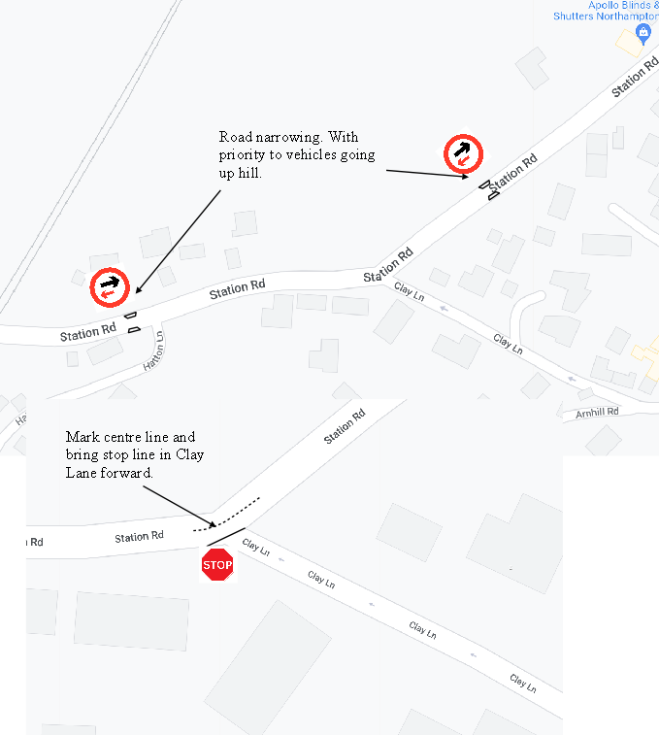
Clay Lane view looking up to the Church is poor, vehicles need to edge out into Station Road before they get a clear view. This coupled with the speed of vehicles and cyclists coming down the hill makes it a risky junction. The width of Station Road at Clay lane junction is a metre (approx.) wider than the rest of the road. This would allow the stop line to be brought forward giving vehicles exiting a much better view.
The two road width restrictions will slow traffic on Station Road. The hedge at the corner of the footpath leading up to Arnhill Road needs to be cut back substantially.

Proposal for Traffic Calming – High St, Kirby Rd, Corby Rd.

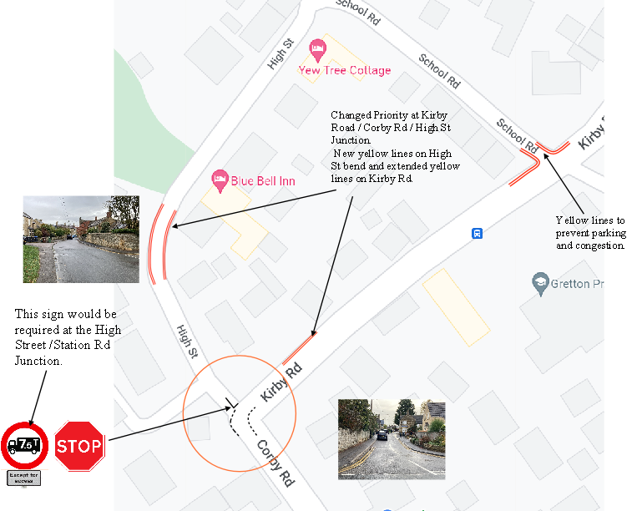

This proposal would divert HGV’s away from the High Street (which is unsuitable for HGV’s) and allow them to turn onto Kirby Road.
The change of priority would cause vehicles from the High Street to stop and reduce near misses. (Vehicles from Kirby Road have a very restricted view to their right.)
The extension of yellow lines on Kirby Road is needed to allow larger vehicles to turn. The lines could be further extended to reduce the congestion that occurs at this point on Kirby Road.
The yellow lines on the bend of the High Street will reduce the congestion, the near misses and allow pedestrians to walk on the footpaths, (a significant number of vehicles park on the footpaths in this area).
Visibility from School Lane into Kirby Road is poor and this is further exacerbated with poor parking at school times. Yellow lines at this junction will reduce the hazards here.
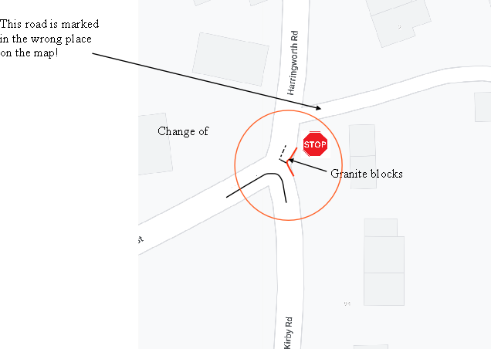
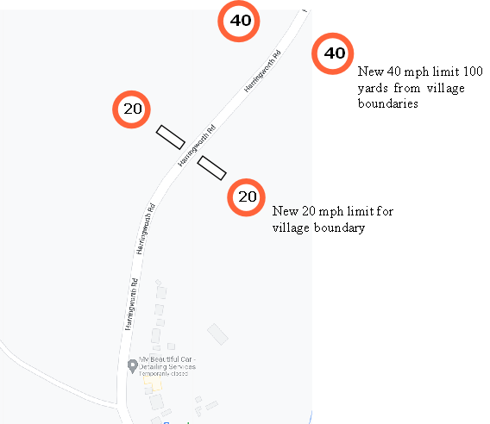
Proposal for Traffic Calming – Harringworth Rd, High St.

Changing the priority of Traffic on this junction and causing the traffic from Harringworth to stop at the blind junction will make turns from the High Street a lot safer and will reduce the speed of vehicles entering Kirby Road.
Proposal for Traffic Calming – Caistor Rd / High St and Kirby Road

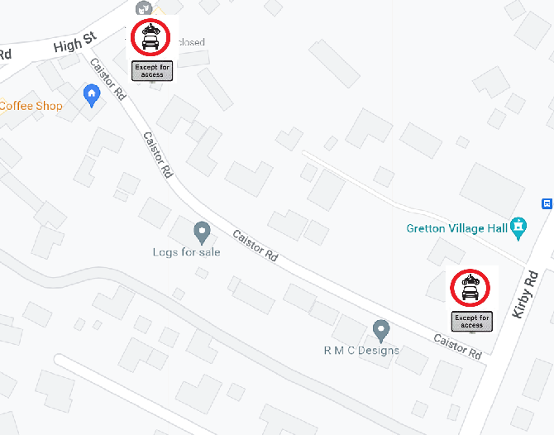
Caistor Road is a narrow Road with no footpath and has caused a number of issues for pedestrians. There are many comments regarding it being too narrow for 2-way traffic
Visibility is very poor at both ends. Making this an access only road will reduce the risks at the junctions and allow pedestrians and horse riders to use it safely. Coupled with the changes at the Harringworth/High Street/Kirby Road will give users a safe alternative route.
The proposal above is one of a number of options. Turning it into a one way road, putting a vehicle barrier halfway down the road and making it ‘residents only’ were other suggestions.

Proposal for Traffic Calming – Arnhill/Clay Lane and Craxford Road.

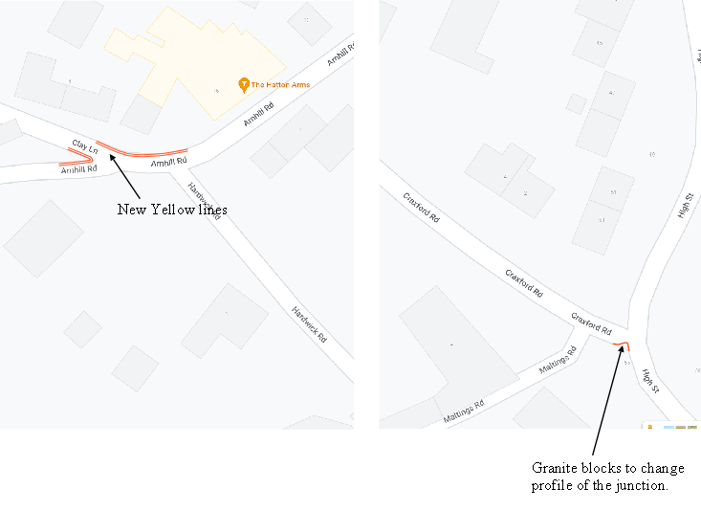
There are issues with parking at the Arnhill Road junction with Clay Lane and with vehicles travelling fast from the High Street into Craxford Road.
The map does not represent the actual layout of the road, On the ground, the High Street runs directly into Craxford Road and vehicles do not always signal coming off the High Street, when they do, the signal can be confused with an intention to turn into Maltings.
Reprofiling Craxford Road Junction with low profile granite blocks will assist here.

Survey Respondents Comments – A Small Selection
Reduce the speed limit
Roads and footpaths in poor condition
Extend yellow line around junctions
The Road is too narrow for 2 way traffic
Residents only traffic – Caistor Rd
Get people to think!
People travel too quickly down Station Rd
Clear the footpath on Station Rd
Cut back Shrubs
Cars parked on Bends
Parking restrictions
Walk to school
Corby Road – too fast
Highway code – what’s that!
Address the issues..
Zebra Crossing Patrol
Parked cars opposite junctions

Footpath obstructions everywhere
Not wide enough for a buggy or wheelchair
Should be double yellows
Dangerous at Clay lane junction
Traffic calming implementation
Cars travel too fast
Education
Cycle route to Corby
Encourage off road parking
Speed Cameras.
40 mph limit like Lyddington
Enforcement

Neighbourhood Plan Section 9 - Extract

Section 9 Transport and Road Safety

Being a Connected Village - Traffic Management
9.1 The village has two main roads; Kirby Road to the east and the High street to the west, both roads running south to north linking the Corby Road and the Harringworth Road. In places both the High Street and Kirby Road can be narrow and very busy, congested, and often crowded with parked cars, especially at school starting and finishing times
9.2 The highways authority currently is NCC (to change to North Northamptonshire in 2021). A wide range of amenities are available within the towns of Corby, Uppingham, Oakham, Market Harborough and Stamford, and Leicester and Peterborough further afield. Gretton is ideally situated for easy access to the A14 & A47, while local trains from Corby (4.5miles) provide regular access to London St Pancras, taking approximately 80 minutes.
9.3 The village has two roads linking the Harringworth Road and Corby Road, Kirby Road and the High Street, both are narrow and can be very busy and is often crowded with parked cars, especially at school starting and finishing times.
9.4 The High Street has some very tight turns and is unsuitable for large and heavy goods vehicles. It is acknowledged that those delivering must enter the village, but the roads are not suited for those passing through, with low bridges on the Harringworth and Rockingham roads.
9.5 Other pinch points in the village are Caistor Road and School Lane, both are single track in places and too narrow for two cars to pass comfortably.
9.6 Residents of Corby Road suffer especially from noise generated by vehicles accelerating and often exceeding the speed limit. NCC traffic flow data can be found at Appendix XI.
9.7 The NPPF encourages a reduction in greenhouse gas emissions through the introduction of measures, which promote a decrease in the number of car journeys. There are several actions that can be taken by individuals and by the public and private sectors to support this objective, although the poor local bus service provision in the village effectively makes car ownership essential.

Cycling
9.8 Gretton is a popular through route for leisure cycling, including international events which have cycled through the village. Businesses have benefitted from this increased attention. However, for the residents cycling to and from work or school, there are no designated cycling road routes from Gretton to Corby or Uppingham. Feedback from the Gretton Plan events highlighted safety concerns for commuters using these roadways. Although there are no strategic local plans to upgrade routes for improved connectivity between Gretton and Corby or Uppingham, it has been suggested that any major developments support an upgrade on existing roadways or footpaths to enable safer transport to employment /schools.

9.9 NCC’s Cycling Strategy can be found at:
www3.northamptonshire.gov.uk/councilservices/northamptonshire-highways/transport-plans- andpolicies/Documents/Northamptonshire%20Cycling%20Strategy.pdf Parking
9.10 There are two public car parks in the village, one at the Village Hall and one at the Recreation Ground. No parking is provided at the churches. The Hatton Arms Public House has a small car park.
9.11 The Baptist Church, the Blue Bell Inn, the Doctor's Surgery and the school are all close to the recreation ground carpark. At the start and end of school times, the car park and all roads around the school are very congested. This is exacerbated when the Doctor's Surgery is open.
9.12 A number of garages are available for rent from CBC at a small fee. These are located on Southfield Road, Fulwell Avenue and Latimer close.
POLICY T1: TRAFFIC MANAGEMENT - With particular regard to the rural highway network of the Parish and the need to minimize any increase in vehicular traffic all housing and commercial development must:
- Be designed to minimise additional traffic generation and movement through the village
- Incorporate sufficient off-road parking in line with housing policy H3
- Not remove or compromise the use of any existing off-road parking areas unless a suitable equivalent alternative is provided
- Provide any necessary improvements to site access, communal parking and the highway network either directly or by financial contributions
- Explore the possibility of introducing appropriate traffic calming
- Consider, where appropriate, the improvement and where possible the creation of, footpaths and cycle ways connecting to Corby and Priors Hall cycle routes.
Community Action T1: Traffic Management - The Parish Council will develop a coherent action plan to address traffic and parking issues that have been identified through the Plan including:
- Undertake an ongoing awareness exercise to make explicit the negative impact on residents of inconsiderate parking
- Work to achieve improvement of car parking provision for the Parish for residents and visitors.
- Introduce community speed reduction actions
- Work with the school to resolve parking issues at drop off and pick up times
Community Action T2: Traffic Calming - The Parish Council to engage with the transport authority with a view to placing Traffic calming measures at entrances to the village and to create a safer village environment giving consideration to safer schemes, such as a 20-mph zone, particularly in the area of the school.

Public Transport
9.13 Local Bus Services – At the time of writing Gretton has no regular bus service. Financial constraints have meant that the NCC has withdrawn its subsidy for local bus services. Unfortunately, prior to NCC withdrawing this service, the village post office and shop closed meaning that there is an increase in demand for public transport to shopping facilities.
9.14 NCC’s Bus Strategy can be found at:
www3.northamptonshire.gov.uk/councilservices/northamptonshire-highways/transport-plans- andpolicies/Documents/FINAL%20Revised%20Bus%20Strategy%20April%202018.pdf
Community Action T3: Public Transport - The Parish Council will continue to lobby the County Council/Unitary Authority to make realistic and economic changes to the service, which match the needs of residents.

Electric Vehicles
9.15 How you travel can have a huge effect on the environment. CBC are recognised as one of the leading boroughs in the preparation of electric charging infrastructure and has been awarded 'Go Ultra Low' organisational status by the Government related to the work in increasing the number of electric vehicles on Corby's roads. The Government has announced through their Clean Growth Strategy that by 2040 all diesel and petrol vehicle sales will be banned. There are a number of incentives to ensure communities are ready for the growth of electric vehicles.
POLICY T2: ELECTRIC VEHICLES - Housing developments which provide charging points for electric vehicles will generally be supported.

The provision of communal vehicular charging points within the Parish will be supported, so long as there is universal access and their presence does not impact greatly on existing available parking in the Parish.

