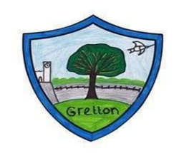
GRETTON PARISH COUNCIL
Email: clerkgpc@btinternet.com
www.grettonparishcouncil.com

All residents of Gretton Parish are invited to attend the Annual Parish Meeting
to be held on Monday 11th April 2022 at 7.00pm.
This meeting will be held in the Meeting Room, Gretton Village Hall,
61 Kirby Road, Gretton. NN17 3DB

AGENDA

01/22 To receive the Minutes of the last Parish Meeting held on 11th May 2020
02/22 To discuss any matters arising from the Minutes
03/22 To receive the Chair’s Annual Report
05/22 To receive the audited accounts of Gretton Parish Council to 31st March 2021
06/22 To receive the accounts of Gretton Village Hall to 31st December 2021
07/22 To receive a financial report from Gretton Pocket Park Society
08/22 To receive the accounts of Gretton Football Club
09/22 To receive the accounts of Gretton Cricket Club
10/22 To receive the accounts of Gretton Sports and Social Club
10/23 To appoint a Police Liaison Representative

Jacki Lilley
Chair of Gretton Parish Council

